



***Project and Change Management (Unit Code: MPP544)***

***Prepared by:***

***WASSIM HASSAN OUTHMAN***

***ID number: 13692***

**Project Title**

**“Zero Pull Out Project”**

**The project was done to stop the pull out of staff nurses from their home units to other units within the same hospital to cover for nursing shortage, which was affecting the nurses’ satisfaction and retention negatively.**

**Executive summary**

According to healthcare experts, the present nursing shortage is going to extend to 2020 with an estimated 400,000 RN vacancies. A number of factors are contributing to the shortage: an increase in the age of registered nurses, decreased school enrollment, increased career opportunities for women, changes in the healthcare delivery system, nurse “burn-out,” and the public’s misunderstanding of what nurses do. It then examines current turnover rates in the NHS and existing estimates of the direct administrative costs and the short-term productivity losses associated with turnover. So, healthcare organizations are trying new ways to attract and retain nurses, not only offering to pay their tuition, but also providing a good and healthy work environment. This has become the reality for many of the nation’s hospitals as many experienced RNs retire and not enough nurses are in the pipeline to fill those positions. This staff turnover in the hospital I am working at, starts to increase. The costs have been increased associated with turnover. It was also noticed that the main cause of the staff turnover was the **nurses’ shortage and pull out** within the hospital units to cover the shortage according to the demands and occupancy of each hospital unit. That was revealed in the exit interviews answer results that was done with nurses who were resigning or not willing to recontract with the hospital. An important approach was done by the nursing administration to treat the nurses’ turnover which was mainly caused by the nurses’ pull out among the unit. The approach was to implement a change project to prevent the nurses’ pull out and making each unit able to cover itself by its own staffing. The main focus in my assignment will be on discussing the implementation of the **“Zero Pull Out Project”**, its aims and nature, phases that were followed, people who were engaged and the closing results and implementation.

**Table of Contents**

Executive summary……………………………………………………………………2

Table of contents………………………………………………………….……………3

Introduction…………………………………………………………………….……3-4

Nature of the case study project………………………………………….….….……4-5

Nature of projects, programs and portfolios and their management……….……5-6-7-8

Governance………………………………………………………………………...9-10

Engaging the stakeholders and teams……………………………………...……...10-11

Monitoring and closing……………………………………………………………11-12

Conclusion……………………………………………………………………………13

References………………………………………………………………………...13-14

**Introduction**

Hospitals are struggling to hold on to experienced and novice nurses alike. Eighteen percent of new nurses will change jobs or even professions within the first year after graduation. An additional one-third leave within 2 years. Nationally, the nursing turnover rate averages 19.1% and is expected to increase, with a nursing vacancy rate of 8%. Nursing turnover can be extremely costly for organizations. Nurses’ pulls out within the hospital units is one of the most cited causes of nursing turnover. Improving the workplace environment positively affect staff satisfaction, burnout, and turnover. The “**Zero Pull Out Project**” is one of the strategies that we implemented to mitigate turnover include: Stopping of nurses’ float throughout the hospital. The main aims of the project were early identified. The nurses were tired from the daily pull out to cover the other units, even by paying them extra money for overtime. All the nurses who resigned or did not recontract, were suffering from working extra shifts as overtime, and covering the shortage of other units by float / pull out. The number of absenteeism and sick leaves have been increased and the obligatory overtime was difficult for being cancelled due to the ongoing shortage of nursing staff in each hospital units. Thus, the “**Zero Pull out Project”** was a creative idea that aimed at the followings:

1. **Eliminate the pull out** of the staff: which was considered as the main nurses’ problem that resulted in the turnover of big number of nurses.
2. **Reduce the amount of absenteeism** among the nurses: which was causing the shortage to get more worse, since the nurses were tired and frustrated.
3. **Reduce the number of the sick leaves** and sick call: as a result of avoiding coming to work for the reason that they were tired and sick, or sometimes pretending sickness was preferred on coming to work and being floated.
4. **Reduce monthly and incremental overtime** and eliminating mandatory overtime that was making the nurses’ schedule so tight with less off / rest days: which in turn, was creating an extra financial burden on the hospital and being more hectic for the nursing staff.
5. **Allow each unit to have adequate staffing** to cover itself without the need of other units’ staff pull out. This will also give the chance of each unit to cancel its own prescheduled overtime.

**Nature of the case study project**

**The project period was set from the beginning of October, 2022 until the end March 2023 in which the tasks were identified and distributed accordingly.**

Identifying the tasks was based on identifying the problem. The main problem of the nurses’ pull out was critically discussed in the nursing administration and there was an eager to remove the problem and set the goals. A root case analysis was done. Frequent meetings with the staff were done including: The Nursing Director, Nursing Managers, Nursing Supervisors, Head Nurses, Team Leaders, staff Nurses and Quality manager. As soon as the pull-out issue was identified, plans were done to resolve the issue. Different opinions were given by the whole nursing staff and goals were set. Everyone agreed that the nurses’ pull-out is a major issue that was affecting the nurses’ satisfaction and turnover which was clearly observed during the answers of the nurses in the previous exit interviews.

The tasks performed were clearly described. The tasks were distributed accordingly as per each nursing position. The Nursing Director assigned the Nursing Manager to properly audit the schedules set by the Head Nurses. The Head Nurses were assigned to cover their own units with their own staffing as per occupancy rate and their patients’ acuities. Extra nurses were provided for each unit through reallocating the staff to their home units and new hires. The Nursing Supervisors were involved to monitor and report the results and ensure no problems are left without any solutions. The Team Leaders were instructed about the issue and the project goals and implementation. Nurses’ opinions were shared clearly and nurses were given the chance to speak up. All nurses agreed to stop the pull-out and were extremely happy to share and help in reaching the project goals.

**Nature of projects, programs and portfolios and their management**

Managing a project is no easy feat, no matter what the scale and scope are. From planning the minutia to handling the ever-changing demands of clients to shipping the deliverables on time, there’s a lot that can go wrong. When you divide the project into manageable stages, each with its own goals and deliverables, it’s easier to control the project and the quality of the output. According to the PMBOK Guide (Project Management Body of Knowledge) by the Project Management Institute (PMI), a project management life cycle consists of 5 distinct phases including **initiation, planning, execution, monitoring, and closure** that combine to turn a project idea into a working product.

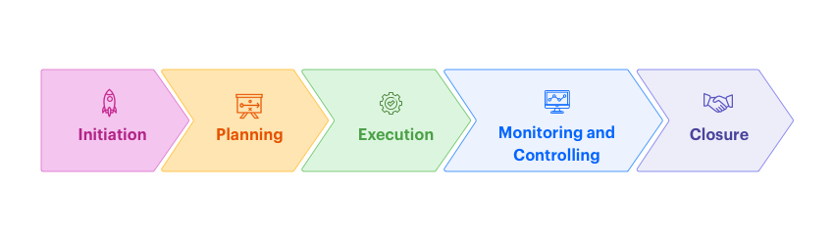 **Phase 1: Project initiation**

The [**project initiation**](https://kissflow.com/project/project-initiation/) phase is the first stage of turning an abstract idea into a meaningful goal. In this stage, we developed the business case and defined the project on a broad level. In order to do that, we determined the need for the project and created a project charter. The [project charter](https://kissflow.com/project/project-charter/) is an important document consisting of details like the [project constraints](https://kissflow.com/project/project-management-constraints/), goals (as mentioned before), appointment of the project manager (Nursing Director), budget, expected timeline (6 months were set). Once we had the project goals and [project scope](https://kissflow.com/project/project-scope-management/), we identified key project stakeholders–the people who are to be involved in the project and Created a stakeholder register with the roles, designation, communication requirements, and influence. While the clear goal of the project was established in this phase, the project charter did not contain any technical details that happen in the planning stage. It is now the time to move to the planning phase and start informing the involved members about the project.

**Phase 2: Project planning**

The [**project planning**](https://kissflow.com/project/steps-to-create-successful-project-plan/)stage requires complete diligence as it lays out the project’s roadmap. In this phase, the primary tasks are identifying technical requirements, developing a detailed [project schedule](https://kissflow.com/project/basics-of-project-scheduling/), creating a communication plan, and setting up goals/deliverables. This was started and followed up by meeting with all the Nursing Managers, the Nursing Supervisors, the Head Nurses, the Team leaders and the staff nurses on weekly basis. In this phase, resistance was obvious and observed through the mentioned staff by feeling worried from the change. It was important to explain for them clearly the staff complaints about pull out and set the goals for solving this problem. After frequent meeting and discussions, the resistance was decreasing and the eager to change was increasing. All staff all staff were prepared mentally and psychologically for change, it was the time to move to the next phase. There were several methods of setting up the project’s goals but S.M.A.R.T. and C.L.E.A.R. are the most popular.

S.M.A.R.T Goals: The ‘SMART’ criteria ensure that the goals we set for our project were critically analyzed. The acronym SMART stands for

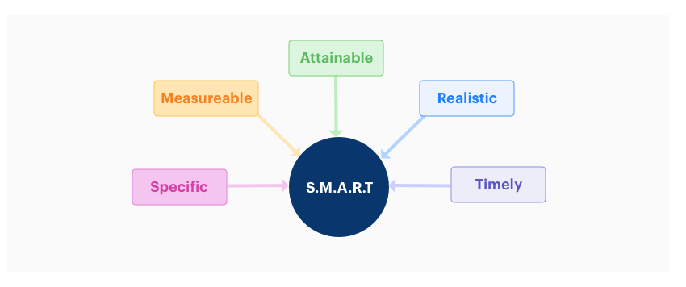

**C.L.E.A.R. Goals:**

The *‘CLEAR’* method of setting up goals is designed to cater to the dynamic nature of a modern workplace. Today’s fast-paced businesses require flexibility and immediate results and CLEAR can help [citizen developers](https://kissflow.com/citizen-development/how-to-become-a-citizen-developer/) with that. The acronym for **CLEAR** stands for:

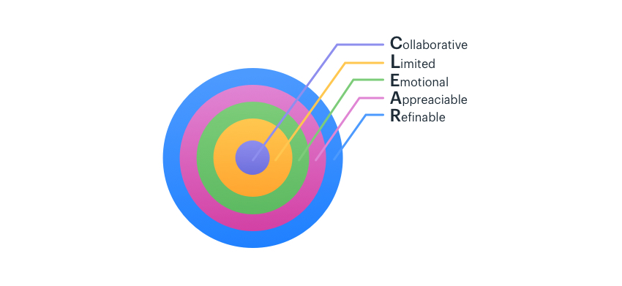

During the planning stage, the scope of the project was defined. An important element that professionals often overlook is an effective change management plan. As a project manager, he must be ready to incorporate a few changes in the project to avoid bottlenecks and [project delays](https://kissflow.com/project/how-to-avoid-project-delays/). In the absence of a working change management plan, [scope creep](https://kissflow.com/project/avoid-scope-creep-in-project/) happens and causes huge problems for the project team in the later stages of the project. So, it’s best to reduce the possibility of unforeseen changes as much as possible.

**Phase 3: Project execution**

The [**project execution**](https://kissflow.com/project/project-execution-phase/) phase where our team started the actual work. As a project manager (Nursing Director), he had the job of establishing [efficient workflows](https://kissflow.com/workflow/how-to-boost-productivity-with-improved-workflow-efficiency/) and carefully monitor the progress of our team. Another responsibility of the project manager during this phase was to consistently maintain effective collaboration between [project stakeholders](https://kissflow.com/project/project-stakeholder-management/). This ensures that everyone stays on the same page and the project runs smoothly without any issues. There was a shift-basis monitoring of the unit coverage with staff, number of sick leaves and absenteeism, hospital occupancy, overtime volunteers and overtime cancellation per each hospital units. The data was collected also and monthly reports were initiated as it will be shown in the **closing part**. Each member of the team was doing his job. The Nursing Managers were monitoring the schedules in parallel with the Head Nurses and were ready to cover any absenteeism or sick leaves. The Nursing Supervisors with collecting and monitoring the whole situation and reporting to the Nursing Director. The team leaders were assigning the number of staff as per the units need in direct and clear communication with the Head Nurses. The Nurses were feeling good at this phase since they were not pulled out of their units and their prescheduled overtime hours were easily cancelled, which allow them to have more rest days with less stress.

**Phase 4: Project monitoring and controlling**

In the project management process, the third and fourth phases are not sequential in nature. The[**project monitoring and controlling** phase](https://kissflow.com/project/project-monitoring-and-controlling/) ran simultaneously with project execution, thereby ensuring that objectives and [project deliverables](https://kissflow.com/project/project-deliverables/) are met. The project manager made sure that no one deviates from the original plan by establishing Critical Success Factors (CSF) and [Key Performance Indicators](https://kissflow.com/project/project-management-dashboard/) (KPI). During the monitoring phase of project management, the manager was also responsible for quantitatively tracking the effort and cost during the process. This tracking not only ensured that the project remained within the budget but also is important for future projects. The overtime cancellation was obviously increasing and the hospital costs were also obviously decreasing. Everything was going on smoothly and continuous monitoring was done by all members**. Exceptions** were not allowed unless for volunteers for overtime to other units for the staff nurses who were not willing for their overtime to cancelled.

**Phase 5: Project closing**

This was the final phase of the project management process. The [**project closure**](https://kissflow.com/project/project-closure-phase/) stage indicated the end of the project after the final delivery. There were times when external talent was hired specifically for the project on contract. Terminating the project and completing the necessary paperwork is also the responsibility of the project manager (Nursing Director). We held a reflection meeting with the whole nursing team after six months of initiating the project and after the completion of the project in order to contemplate their successes and failures during the project. This was an effective method to ensure continuous improvement within the hospital to enhance the overall productivity of the team in the future. The final task of this phase was to review the entire project complete a detailed report that covers every aspect. All of the necessary data was stored in a secure place that can be accessed by project managers of that organization.

**Governance**

* **Nursing Director**: Or the **Project Manager** was the first key person for starting the project and had the greater responsibility to delegate the tasks and monitor the work flow as planned to fulfill the goals and reach positive results. He asked for a shift-based results which were collected on monthly basis. He also monitored the main factors the project was based on where no pull out was accepted for any reason except for nurses who volunteered to work overtime in other unit with their full will. No obligations were allowed.
* **Nursing Manager:** Was responsible to monitor all the staff monthly schedules that were set by the head nurses. The extra staff who were pulled out from their units during the COVID-19 period to cover the Intensive Care Units and Emergency Room were returned back to their home units. Thus, the shortage was reduced and overtime was set in each unit with less prescheduled hours. The Nursing manager was there at all times to help in covering the units if any sick leaves or absenteeism, ensuring no pull out is done and the unit is covered by adequate staffing.
* **Nursing Supervisor:** will no longer interfere in the units staffing unless there was a critical issue not being solved by the Head Nurse or Nursing Manager out of duty hours. It is the duty of the Nursing Supervisor to ensure that the units are adequately covered with staffing, and report the results on shift-basis to the Nursing Administration. Direct communications with the Head Nurses and the Nursing Manager regarding any staffing issue helped a lot in solving it.
* **Head Nurses:** Were responsible for setting the monthly staff schedule under the direct supervision of the Nursing Manager. If the staff are not adequate for any reason, frequent changes in the staff schedule is done to cover for daily basis. If changes in the schedule were not possible, it is the responsibility of the Head Nurse to cover as a team leader and have the team leader handling patients to achieve full unit coverage. Also, it is the responsibility of the Head Nurses to monitor the need of the unit for the staff and cancel the extra overtime hours that are not needed.
* **Team Leaders:** Were responsible to assign the nurses in the units as per the agreed acuity and ration. If there was a higher acuity or ration greater than expected, it was the team leader job to report shortage of higher acuities to the Head Nurse to act immediately on covering the unit with adequate staffing.
* **Staff Nurses:** Were given the full right to refuse and report any obligatory pull out or to work as voluntary overtime “**Volunteers**” in other units as per their own will.

**Engaging the stakeholders and teams**

The first idea that came to our minds together with the project manager was the way to deal with people who might resist the project management in our hospital and how to deal with resistance to change and make people more flexible and accept the change. Whether you are leading a challenging project, you may have resigned yourself and feel there's nothing you can do. Development of a plan that makes the stakeholders engaged in the project was important. Proper Identification and assessment of our stakeholders was done.

**10 Ways were followed to Engage Project Stakeholders**

**Stakeholders were identified early.** We could not engage the stakeholders until we knew and determined them clearly before initiating our projects. Additionally, we [created a project stakeholder register.](https://projectriskcoach.com/how-to-create-and-use-a-stakeholder-register/)

**Get stakeholders talking to one another.** I invited key stakeholders to my initial project meetings as we were developing the project charter. I wanted to surface and resolve the conflicts as soon as possible.

**Seek to understand before being understood.** Steven Covey shared this principle years ago. It still holds true. Furthermore, people wanted to know that we really wanted to hear their perspective first.

**Listen, really listen.** Part of understanding was making time to sit face-to-face, when possible, and [truly listen](https://hbr.org/2016/07/what-great-listeners-actually-do). Ask probing questions.

**Lead with integrity.** Meaningful engagement requires trust. We Said what we meant; we meant what we said. And then we did what we said we would do.

**Engage your stakeholders in the estimates.** We asked the people that will do the work for estimates and helped the stakeholders to understand that [there was a greater uncertainty in the early estimates](https://projectriskcoach.com/improve-schedule-estimates/). We committed to providing refined estimates as our projects progressed.

**Work with your team.**  This helped everyone to have a better understanding of the project. Furthermore, stakeholders more likely supported the plan that they helped creating it, and here was the great engagement.

**Manage expectations.** Each of our stakeholders had different expectations, sometimes false expectations. Working with our team clarified many of these aspects of the project.

**Say thank you.** The project managers and me enjoyed most know two simple words: **Thank you**. When team members and other stakeholders’ complete activities, respond to emails and voicemails, made us aware of things we didn’t know, [respond with thanks](https://projectriskcoach.com/10-simple-ways-to-thank-your-team/).

**Communicate, communicate, communicate.** Ninety percent of a project manager’s job was direct and clear communication. Communications plan was developed and maintained. Potential communications breakdown was minimized by communicating through a variety of channels, not one or two. Example: E-mails and WhatsApp groups.

**Monitoring and closing**

It is the time to end the project and evaluate the outcomes. A monitoring and evaluation (M&E) plan final document done by the project charter helped to track and assess the results of the interventions throughout the life of the PI project. It was the living document that was referred to and updated on a regular basis (Shift basis). We followed the same basic structure and included the same key elements that were set as our goals.

The M&E plan included some documents that have been created during the project planning process, and some that will need to be created new. For example, elements such as theory of change, and [monitoring indicators](https://thecompassforsbc.org/how-to-guide/how-develop-indicators) may have already been developed with input from [key stakeholders](https://thecompassforsbc.org/how-to-guides/how-conduct-stakeholder-workshop%20) and/or the program donor. It was important to develop an M&E plan before beginning any monitoring activities so that there was a clear plan for what questions about the program need to be answered. This will ensure there is a system in place to monitor the program and evaluate success. It helped the project staff decide how they were going to collect data to track [indicators](https://thecompassforsbc.org/how-to-guide/how-develop-indicators), how monitoring data will be analyzed, and how the results of data collection will be disseminated both to the donor and internally among staff. At the end of the project which took six months (From October 01, 2023 until March 30 2023) the plan and goals that were set earlier and clearly at the beginning of the project, were all achieved. **The results were amazing**. The following table reflects the huge difference within the results compared to the previous months within the past 2 years:

|  |  |  |  |  |  |  |
| --- | --- | --- | --- | --- | --- | --- |
| **Zero Pull Out Project** | | | | | | |
| **2021 versus 2022** | | | | | | |
| **2022 versus 2023** | | | | | | |
| **Key Performance Indicators** | | | | | | |
| **Period** | **Pull Out Staff** | **Absent Staff** | **Sick Leaves** | **Cancelled Overtime Per Hour** | **Department Coverage** | **Occupancy Rate** |
| **Oct-2021** | 353 | 22 | 27 | 5350 | 100% | 64% |
| **Oct-2022** | **0** | **1** | **24** | **5204** | **99.43%** | **75%** |
| **Nov-2021** | 323 | 33 | 47 | 3131 | 100% | 66% |
| **Nov-2022** | **0** | **4** | **24** | **3706** | **99.80%** | **75%** |
| **Dec-2021** | 382 | 27 | 45 | 5296 | 100% | 59% |
| **Dec-2022** | **0** | **3** | **17** | **6012** | **99.30%** | **70%** |
| **Jan-2022** | 349 | 33 | 168 | 3600 | 100% | 90% |
| **Jan-2023** | **0** | **9** | **30** | **6094** | **99.90%** | **69%** |
| **Feb-2022** | 333 | 13 | 55 | 1564 | 100% | 69% |
| **Feb-2023** | **0** | **2** | **18** | **10672** | **99.60%** | **71%** |
| **Mar-2022** | 324 | 38 | 47 | 4176 | 100% | 67% |
| **Mar-2023** | **0** | **2** | **34** | **15322** | **99.90%** | **68%** |

.

**Conclusion**

Performance improvement project or PI projects at health care facilities, represents one of the enduring challenges to change. It took over years of constant searching to gain the understanding of PI that humanity has today. It is an important module that helps identifying the issues and work in a systematic way to overcome these issues and enhance the quality of practice and care at the workplace. **PI projects** are made not only to improve the quality of practice, but also to facilitate the process of work flow on the staff. When PI project is done and implemented successfully through the right process, it reflects an excellent impact on patients and staff outcomes and satisfaction. No matter how good people become at performing PI projects, its complete mystery has yet to unravel. It will always be important in some of the most fundamental applications of nursing development and improvement. **PI project** encompasses implementing the best-known practices into the clinical setting using a scientific approach. As a result, safe, high-quality, and cost-effective care will be more likely to occur consistently. The well-developed health care institutions are always looking for the best quality of care and trying to identify their gaps in patients’ care, and address those gaps as a serious alarm. As a results efforts are continuously being focused on the gaps in practice and ongoing trials and processes are followed to narrow the gaps and achieve safer care and perfect satisfaction.

**References**

Author affiliations: SMBF LLC Healthcare Consulting. (n.d.). *The nursing shortage: Past, present, and future: Jona: The Journal of Nursing Administration*. LWW. Retrieved April 10, 2023, from https://journals.lww.com/jonajournal/Abstract/2002/02000/The_Nursing_Shortage__Past,_Present,_and_Future.5.aspx

Author links open overlay panel Alastair M. Gray a, a, b, c, Abstract This article reports empirical evidence on the costs of nursing and other staff turnover in the National Health Service. It begins by considering the possible costs and benefits associated with turnover. It then examines current turnover rates in, Gray, A. M., Phillips, V. L., Parsons, D. A., UKCC (United Kingdom Central Council for Nursing, & Fox, J. (1999, February 19). *The costs of nursing turnover: Evidence from the British National Health Service*. Health Policy. Retrieved April 10, 2023, from https://www.sciencedirect.com/science/article/abs/pii/0168851096008548

*5 phases of Project Management Process - a complete breakdown*. Kiss flow. (n.d.). Retrieved April 13, 2023, from https://kissflow.com/project/five-phases-of-project-management/#:~:text=According%20to%20the%20PMBOK%20Guide,idea%20into%20a%20working%20product.

Hall, H. (2022, September 10). *10 ways to engage project stakeholders*. Project Risk Coach. Retrieved April 13, 2023, from https://projectriskcoach.com/engage-project-stakeholders/

Hall, H. (2022, September 10). *https://thecompassforsbc.org/how-to-guide/how-develop-monitoring-and-evaluation-plan*. Project Risk Coach. Retrieved April 13, 2023, from https://projectriskcoach.com/engage-project-stakeholders/

Hall, H. (2022, September 10). *ubmed.ncbi.nlm.nih.gov/12887226/#: ~:text=Conclusion%3A%20Evidence-based%20practice%20encompasses, more%20likely%20to%20occur%20consistently.* Project Risk Coach. Retrieved April 13, 2023, from https://projectriskcoach.com/engage-project-stakeholders/

# 